**Join us for the 2017-2018**

**HCOE English Learner**

**Collaborative!**

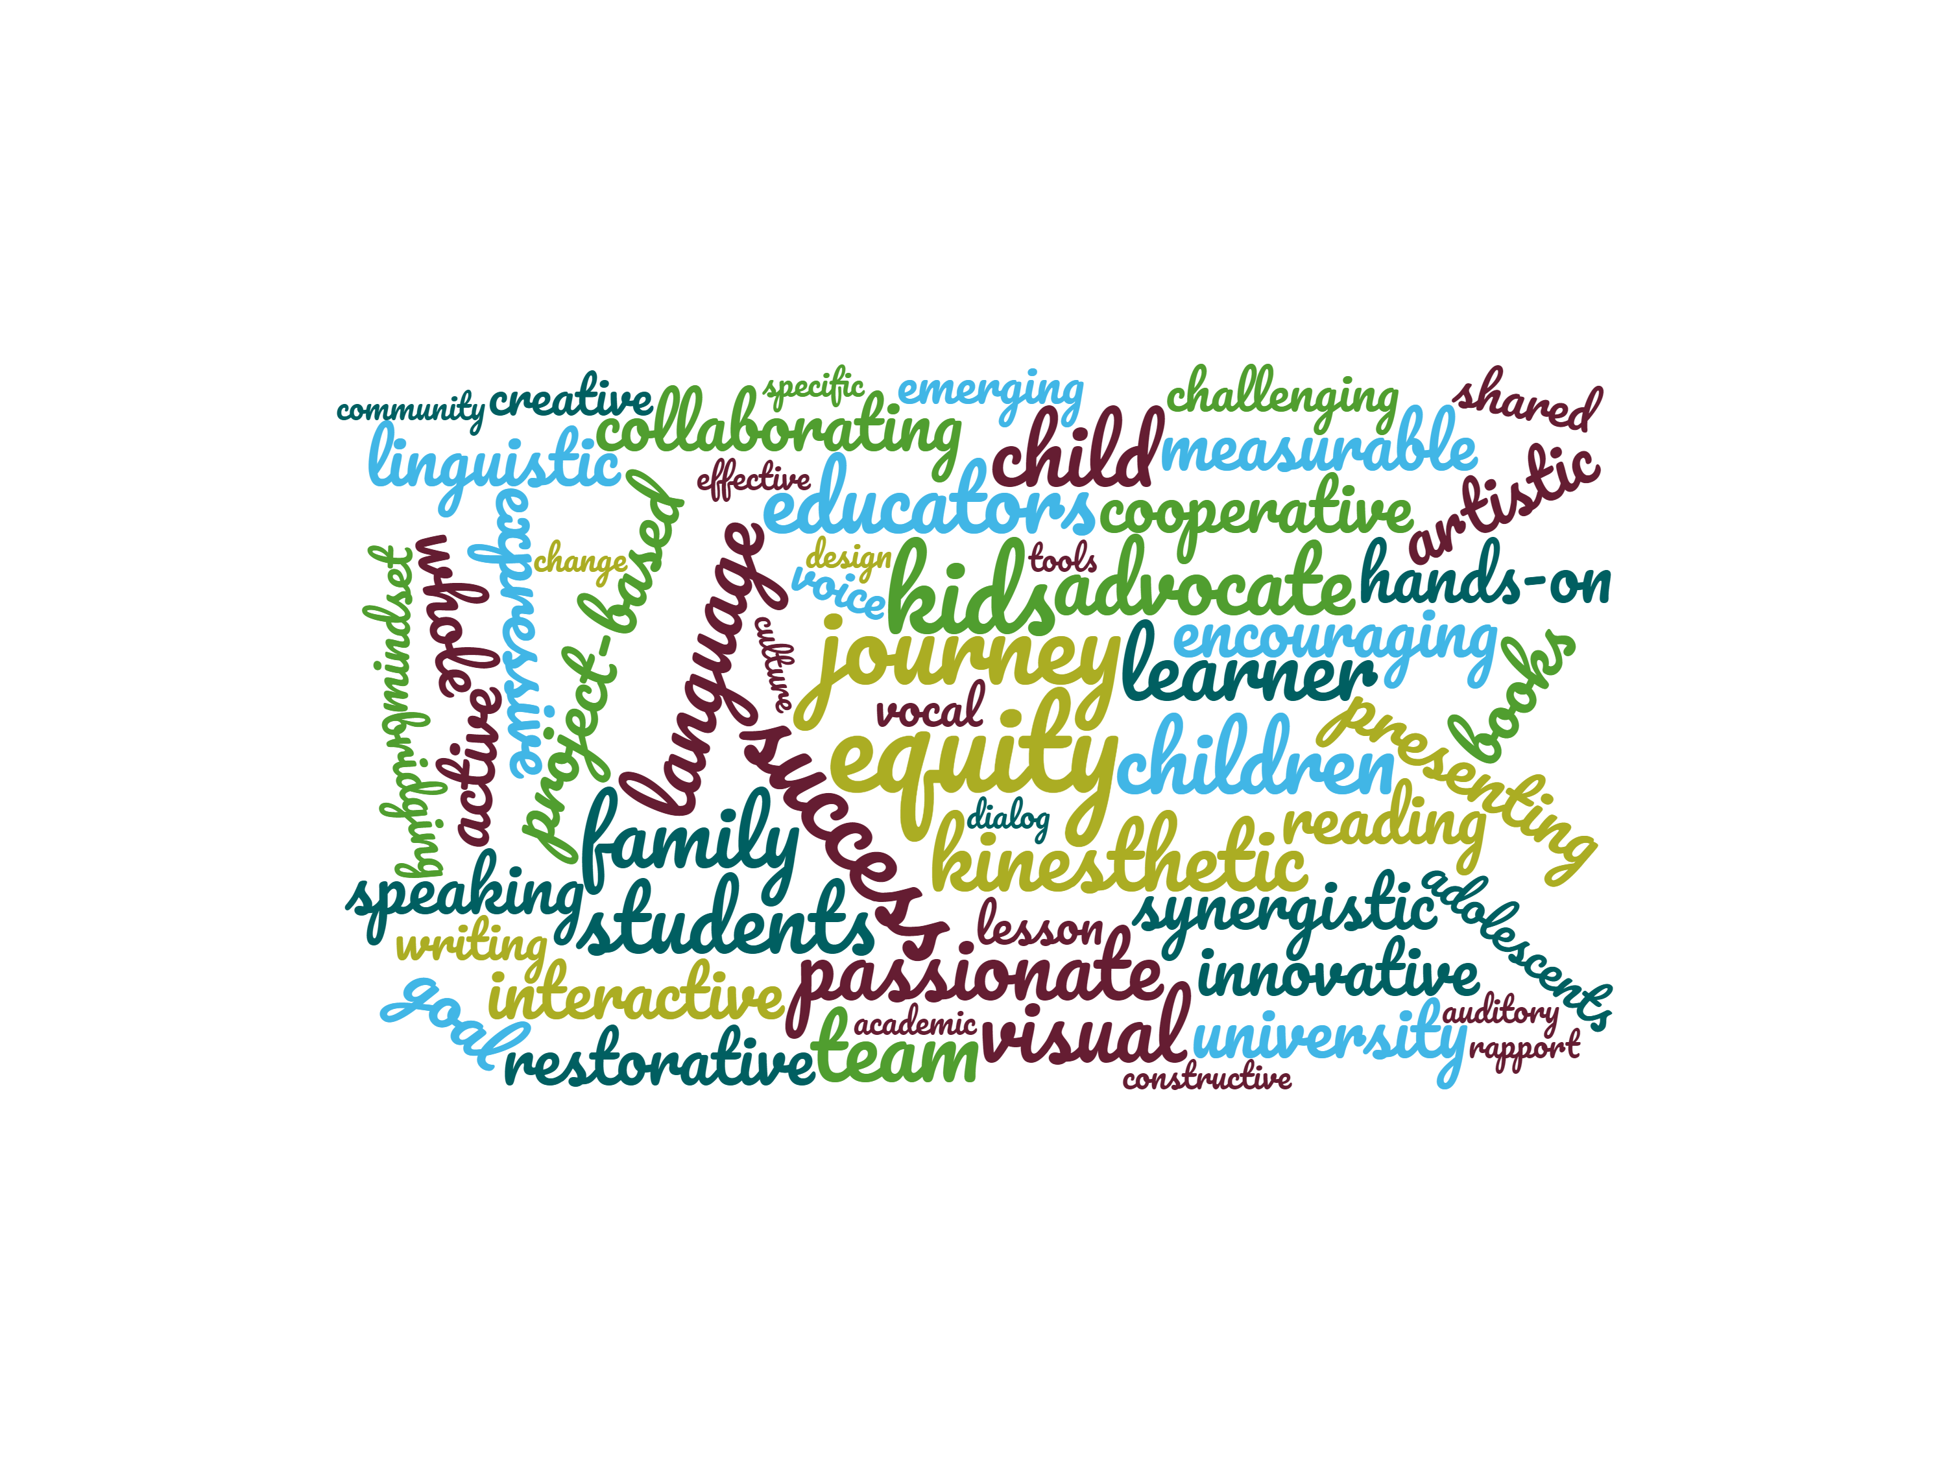

**Meeting Dates 2017-2018**

**Sept. 25 Oct. 23 Dec. 4 Jan. 8**

**Feb. 5 Mar. 5 Apr. 2 May 7**

**3:45 – 5:00 pm in the HCOE Annex-last meeting in Redwood, $95 for 8 sessions**

**Agustín Amaro M.Ed. Facilitator, for more info:** [**aamaro@hcoe.org**](mailto:aamaro@hcoe.org)

**Cell/Text: 707-502-4343/ Registration:** [**http://my.hcoe.net**](http://my.hcoe.net) **/Course # 78180**

**Free materials, resources, and snacks will be provided!**

Save time by sharing!

Strategies & lesson ideas!

Workshops on topics you choose!

Updates on requirements from the California Department of Education!

Feeder school coordination

Encouragement & problem solving!

https://sites.google.com/site/hcoeelcollaborative/

***The EL Collaborative supports new and veteran teachers, aides and administrators working with English learners at all levels.***

***The collaborative meets monthly after school at HCOE.***